MDEA Bogey Calculation Method

The MDEA bogey is calculated based on the cost of generating power to meet the MDEA day-ahead load forecast after adding long term contract power. The generated power is calculated by optimizing the available generating assets for heat rate. The bogey is calculated for each hour then averaged for the day. Generation is added during peak times for 16 hours if possible with a minimum run of 12 hours.

The largest component of the cost of generation is gas cost. The gas cost per MW is calculated based on the assumed heat rates for each unit. Since there are no manufacturer’s heat rate curves or equations for the MDEA units, the heat rates are based on data received from MDEA during the meetings held in Houston. The next largest cost component is the start-up costs. The start-up costs are also based on assumptions and were discussed during the Houston meeting. As better data is received, the heat rate and start-up costs can be adjusted accordingly. The other cost component is the fixed O&M cost per MW. The following table lists the assumptions used to determine heat rate, start-up and run costs.

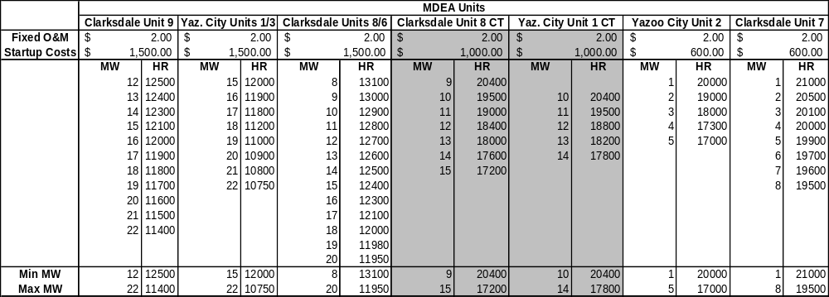

The gas cost is determined by the delivered price to each city. The gas cost is negotiated on a day-ahead basis with the gas suppliers.

The load forecast is a correlation based on historical load data and forecast weather conditions. A software package called MetrixND is used to calculate the forecast for a two-week forward period each day.

An Excel spreadsheet application is used to calculate the bogey based on all of the above information. This spreadsheet has macros that collect the load forecast data and the unit data. The first step is to load the forecast load data. Once this data in input, generation is added until the forecast load is met. The generation is added based on the available units with the best heat rates. The order of preference if all units are available is: CD9, YZ1/3, CD8/6, YZ2, CD7. The unit availability sheet faxed to Enron each day is used to determine which units are available.

A unit can only be added if its minimum MW output is at least as much as the requied generation. For example if the forecast is for 25MW load and the long-term contracts fill in 20MW, the difference if 5MW. The CD9, YZ1/3 and CD8/6 units cannot be used since they all have a minimum MW rating of more than 5MW. Therefore YZ2 or CD7 would have to be used.

If the required MWs are in the range of a generator it is added by itself. For instance, if the forecast is 35MW and the long-term contracts fill in 17MW, the difference is 18MW. CD9 would be added to the generation stack at 18MW.

If two or more genrators are needed to meet the load, the heat rates are optimized. For example if the forecast predicts a 45 MW load and the long-term contracts cover 10MW, there is still 35 MWs that need to be filled. The first unit to be added is CD9. CD9 adds a maximum of 22 MWs leaving 13 MW required. The next unit to be added would be YZ1/3. The outputs of the two generators are then adjusted so that the combined heat rate is lowest for an output of 35 MW.

Once the generation is added to the stack and the load is met, the bogey is calculated for each run hour. The calculations for determining the bogey follow:

As an example, CD9 is set to generate 20MW for 16 hours and the gas price is $4.35/MMBtu.

Gas Price = $4.35/MMBtu
MWhr/hr = 20 MWhr
Heat Rate for CD9 at 20 MW = 11.6 MMBtu/MWhr
Run Time = 16 hrs.
Start-up cost for CD9 = $1500
Fixed O&M for CD9 = $2.00 /MWhr

Gas Cost/MWhr = $4.35/MMBtu * 11.6MMBtu/MWhr
= $50.34/MWhr

Amortized Start-up Cost/MWHr = $1500/(16Hrs*20MWhr)
= $4.69/MWhr

Fixed O&M for CD9/MWhr = $2.00/MWhr

These are then added to get the total cost per MWhr.

Gen Cost/MWhr = Gas Cost + Amortized Start-up Cost + Fixed O&M Cost = $50.34 + $4.69 + $2.00
= $57.03

For a 16 hour run, the costs are averaged for the entire run and the bogey is determined. In this case, 20MW are generated for each hour so the bogey would be $57.03.

If more than one generator is running, a weighted average heat rate is used to determine the bogey using the calculations above.

A sample screen print of the bogey calculation spreadsheet is shown below:

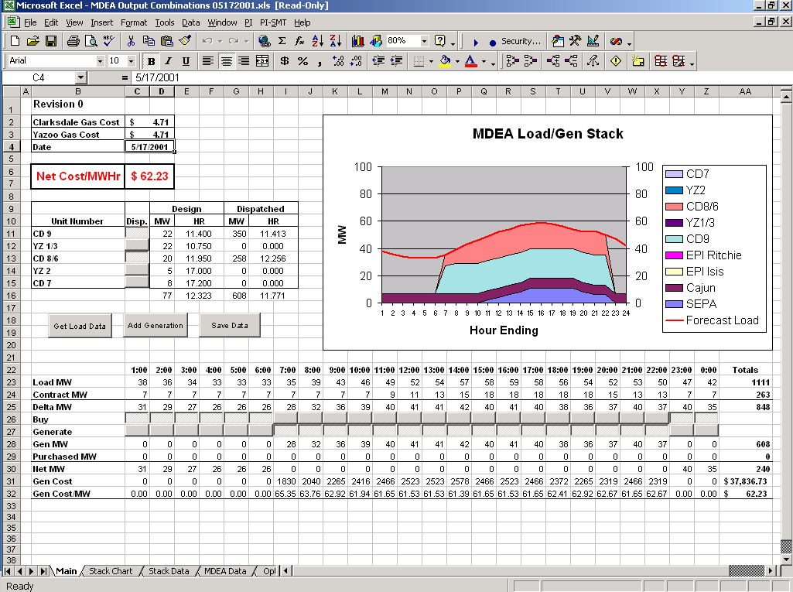
The sheet shows at the top left the gas price for the day for each city, the date of the forecast, the bogey price, which generators are comitted and how many MWs are dispatched for the day with the average heat rate. To the right is a chart showing the forecast load with the contract and generation stack required to meet the load. At the bottom of the sheet is an hour by hour table of the load forecast, the contract MWs, total generation, total generation costs and generation costs per MWhr. A copy of this sheet will be saved for each day until a database with all of the data can be created.

